APPLICATION FOR SUBMISSION TO
THE DALHOUSIE UNIVERSITY SOCIAL SCIENCES AND HUMANITIES
RESEARCH ETHICS BOARD

THIS FORM SHOULD BE COMPLETED USING THE FOLLOWING DOCUMENT:

‘GUIDANCE FOR SUBMITTING AN APPLICATION FOR RESEARCH ETHICS REVIEW’

SECTION 1. ADMINISTRATIVE INFORMATION

Project Title
3D Object Clouds: Viewing Virtual Objects in Interactive Clouds on Mobile Devices

1.1 Local Principal Investigator [Lead researcher affiliated with Dalhousie University]
Name | Xiaoting Hong
Department | Faculty of Computer Science
 |  |  | Phone | 902 989 0211
Email | x.hong@dal.ca |  | Fax | -
For student  submissions | Supervisor’s Name/Department | Dr. Stephen Brooks/ Faculty of Computer Science
For student  submissions | Supervisor e-mail & phone # | sbrooks@cs.dal.ca , 902-494-2512
For student  submissions | Degree Program | MCS (Thesis Stream)

Co-investigator(s)  Names and affiliations | Dr. Stephen Brooks, Faculty of Computer Science

1.2 Signature of Local PI attesting that:
a. All co-investigators have reviewed the ethics submission and are in agreement with it.
b. All investigators have read the Tri-Council Policy Statement Ethical Conduct for Research
Involving Humans and agree to abide by these guidelines

Signature Date
------------------------------------------------- ------------------------------------

Other ethics reviews (if any) |  |  | Where
 |  |  | Status
Funding (if any) | Agency |  |  | NSERC
Funding (if any) | Award Number |  |  | CRDPJ 436576-12
Peer review (if any)
Planned start date | July 2015 |  |  |  | Planned end date |  | August 2015
Contact person  for this submission  (if not PI) | Name
Contact person  for this submission  (if not PI) | Email |  |  |  |  | Phone

SECTION 2. PROJECT DESCRIPTION
[Complete all parts, referring to the Guidance Document corresponding to this form]

2.1 INTRODUCTORY SUMMARY [250 words max]
2.1.1 briefly describe the rationale, purpose, study population and methods

The focus of this work is the browsing, selection and comparison of a collection of 3D objects on mobile devices. Collections of objects are arranged in the form of interactive 3Dclouds, analogous to 2D tag clouds commonly used for text. The position of each object in relation to surrounding objects has meaning and the relative selection of views of individual objects is based on multiple canonical views. The aim is to assist the user in obtaining clearer insights of object features and differences between clusters of objects. The user is able to crawl through the space of objects with simple gestures, while the system adapts the arrangement of the 3D cloud in real time. Prior work is mostly focused on presenting text/ tags, or 2D images. Our system expands this concept to 3D objects. A user based evaluation will be conducted with the members from Dalhousie University community. Participants will be asked to complete various selection tasks using different spatial arrangements and animated transitions. We will capture their performance through logging software and will record their verbal expressions, including interview responses, with an audio recorder. After completing 3D browsing and selection tasks, participants will fill out a questionnaire to allow us to further explore their perceptions of the technique and then we will interview the participants to obtain more feedback for future improvements.

2.2 BACKGROUND AND PURPOSE - In this section discuss [3 pages max, not including references]

2.2.1 Why there is a need to undertake the study (including a brief literature review)

Viewing a collection of 3D objects involves the comparison of many important details. And with the advent of technologies such as 3D printing and the associated communities of professional and amateur object designers that have arisen, the browsing and selecting of 3D objects is becoming a more prevalent activity by specialists and non-specialists alike.

In parallel with this, the viewing of 2D images and text tags in cloud information has become a widely used method for visualizing and presenting information [1]. Tag clouds draw users’ attention to important information and highlight the overall patterns and trends. Prior work has mainly focused on the viewing of 2D tags [1] [3] [4] but has recently been extended to the viewing of 2D image clouds [2]. The exploration of 3D clouds has largely been uncharted. The development of 3D object clouds poses unique challenges and opportunities given the higher degree of freedom regarding the orientation and rendering of the individual objects.

The orientation of individual objects will be governed by algorithms that compute canonical views for objects based on the analysis of potential points of interest or unique geometric features found on the 3D objects. Different methods that compute canonical views have been developed [8][9][10][11], and their effectiveness for computing informative views of individual objects has been studied [5], but only for viewing individual objects, not for sets of clustered objects in a cloud formation. We will study the effectiveness of two different uses of canonical views in 3D object clouds: using multiple canonical views of objects within each cluster of similar 3D objects in the cloud, and using a single uniform canonical view for all objects in a cluster of similar 3D objects in the cloud.

Thus, we are exploring the presentation of 3D objects in the form of clouds as a potentially more structured and informative way to browse, understand and select objects. The user will sequentially select a series of objects of interest within the available set of 3D objects by direct touch selection. After each selection by the user, this newly selected object then becomes the new focal point within the space of available 3D objects. After each selection step a new set of objects will be presented to the user, which is more similar to that object which has just been selected. In this way the user is able to sequentially crawl through the set of available objects until they reach the object or objects of interest.

The interactive-layout not only enables the user to adjust the cloud’s focus in the arrangement, but also incorporates staggered animations [6] to help maintain visual coherence as the focus moves through the space of objects. By this we mean that the movement of objects within view, given a new selection by the user will not be linear but will occur in staggered phases to allow to the user to follow the movement of multiple objects that remain in view. The effectiveness of this has been shown [6] for dynamic changes of values for simple visualizations such as bar charts and pie charts, but the effectiveness of such a technique for 3D objects has not yet been explored.

Also of notes is that our system is designed to be interactive and implemented on mobile devices. Thus, we are constraining the design of our algorithms to operate in real time with limited power.

2.2.2 What new knowledge is anticipated as an outcome of the study

Both in terms of standard practices in industry and prototype systems found in research, the existing approaches are mostly focused on presenting the 2D contents (image, text) in a packed cloud-like view. Our study provides a novel way to browse, select and compare a collection of 3D objects in an interactive cloud view. We will test whether this novel design will provide an effective way to present 3D objects, and also offer insight into the design of such systems to inspire further related approaches.

2.2.3. If this is intended to be a pilot study, or a fully developed project

This is a fully-developed project.

References:

- Scott Bateman, Carl Gutwin, and Miguel Nacenta. Seeing Things in the Clouds: The Effect of Visual Features on Tag Cloud Selections. In Proceedings of the ACM Conference on Hypertext and Hypermedia (Hypertext ‘08). Pittsburg, US, June 2008: 193-202.
- Bernhard Reinert, Tobias Ritschel and Hans-Peter Seidel. Interactive By-example Design of Artistic Packing Layouts. In ACM Transactions on Graphics, Vol.32, Issue 6. November 2013: Article No.218.
- Erick Gomez-Nieto, Frizzi San Roman, Paulo Pagliosa, Wallace Casaca, Elias S.Helou, Maria Cristina F. de Oliceira, and Luis Gustavo Nonato. Similarity Preserving Snippet-Based Visualization of Web Search Results. In IEEE Transactions on Visualization and Computer Graphics, Vol.3, Issue 3. March 2014: 457-470.
- Jonathan Feinberg. Wordle. In Beautiful Visualization, Chapter 3. July 2010: 37-58.
- Helin Dutagaci, Chun Pan Cheung, Afzal Godil. A Benchmark for Best View Selection of 3D Objects. In Proceedings of the ACM workshop on 3D object retrieval. October 2010: 45-50.
- Jeffrey Heer, George G. Robertson. Animated Transitions in Statistical Data Graphics. In IEEE Transactions on Visualization and Computer Graphics, Vol.13, Issue 6. 2007: 1240-1247.
- Ka-Ping Yee, Danyel Fisher, Rachna Dhamija, and Marti Hearst. Animated Exploration of Dynamic Graphs with Radial Layout. In Information Visualization. Washington, DC, USA, 2001: 43-50.
- O. Polonsky, G. Paysne, S. Biasotti, C. Gotsman, and M. Spagnuolo. What’s in an image? The Visual Computer. 21(8-10). 2005: 840-847.
- Pere-Pau Vazquez, Miquel Feixas, Mateu Sbert, and Wolfgang Heidrich. Viewpoint Selection using Viewpoint Entropy. In VMV 2001. Stuttgart, Germany, November 21-23, 2001: 273-280.
- D. L. Page, A. F. Koschan, S. R. Sukumar, B. Roui-Abidi, M. A. Abidi. Shape Analysis Algorithm based on Information Theory. In Image Processing, ICIP 2003, Vol.1. Sept 2003: 229-232.
- Chang Ha Lee, Amitabh Varshney, David W. Jacobs. Mesh Saliency. In ACM Transactions on Computer Graphics, New York, USA. 2005: 659-666.

2.3 STUDY DESIGN – In this section

2.3.1 State the hypotheses or the research questions or research objectives

- Comparative evaluation of spatial arrangement techniques for viewing a collection of 3D objects on mobile devices: out interactive 3D-object cloud and the standard grid-based view that is used extensively in commercial systems.
- Comparative evaluation of animation techniques for viewing a collection of 3D objects on mobile devices: staggered animated transitions and linear animated transitions.

2.3.2 Describe the general study design and how it will address the hypotheses / questions objectives.

In the study process, each participant will conduct tasks with each participant browsing 3D objects. Multiple 3D spatial arrangement techniques (cloud based using multiple canonical views, cloud based using uniform canonical views, and standard grid based views) and tasks will be evaluated using models (vehicles, common household objects, etc) that are commonly found on commercial and amateur 3D model repositories. For example, task one might be “find the target model shown on the screen starting with the given set of 3D models shown”. There will be two groups of studies to evaluate the 3D spatial arrangement techniques and animations respectively In each group, each task will take into account one aspects of the study, which are the 3D object browsing techniques (cloud with multiple views vs. grid view) and the type of animation (staggered vs. linear). While these tasks are performed, we will be carefully observing the movement of a participant’s finger and recording that information with logging software will give us a precise account of the interaction. By recording the timing of finishing tasks using different browsing 3D objects techniques, we can compare them and obtain the results to see if our approach improves the performance of selecting targets from a large set of 3D objects on mobile devices, and determine which configuration produces the best results.

2.3.3 Describe how many participants are needed and how this was determined.

We will recruit 48 participants to take part in this study. We have two groups of study. In each group, we have two variables of interest: 1. In the first group, the variables are the 3D object browsing techniques (2 types) and type of dataset (3 types); 2. In the second group, the variables are the type of animation (2 types) and type of dataset (3 types). Thus, in each group, we need at 12 participants in order to counterbalance our conditions, and we will run two participants in each ordering, requiring a total 24 participants. There will be 48 participants needed in total for the entire user study.

2.3.4 Describe the plan for data analysis in relation to the hypotheses/questions/ objectives

There will be five aspects to data collection. First of all, we will record the audio of participants while they perform tasks; we anticipate that participants may express frustration or describe their intensions while performing the tasks. We will use this information to help interpret the log data, described next. Second, the timings and tracks of fingers will be recorded by logging software. Third, there will be background, spatial ability test and tasks related questionnaires to fill out by participants. Fourth, after all the tasks are finished, we will conduct a short interview about the experience of using our application and the two selection techniques. Fifth, we will videotape the procedure while the participants are performing tasks. The timing of finishing tasks will be our objective quantitative measure of performance; responses to rating questionnaires will give us subjective quantitative data such as the degree of user satisfaction with the interface and confidence about finishing tasks. Analysis of the tracks of fingers and the recordings of participants’ verbal expressions during the tasks will provide us with information about how participants interact with 3D models on mobile devices and where they were having difficulty (i.e., errors in selection, etc.). The data will give us information that will allow us to further refine our interface. The spatial ability test will reveal if there is an underlying pattern between the participants’ spatial abilities and their performance or preference. The video records may reveal the potential behaviours which will indicate their strategies and when these strategies are challenged. Post-session interviews will provide us with additional feedback, which might not be apparent in the previous data and will help us to more comprehensively understand the preference of a participant’s choices in terms of these object presentation and selection techniques. Participants will complete Appendix F: Post-task Questionnaire 6 times for the two 3D object browsing techniques, while they will complete Appendix E: Post-task Questionnaire 6 times for the two types of animation.

2.3.5 If a phased review is being requested, describe why this is needed for this study and which phases are contained in this application

N/A
2.4 RECRUITMENT – In this section, for each type of participant to be recruited, describe

2.4.1 the study population
2.4.2 any social / cultural / safety considerations
2.4.3 and justify all specific inclusion / exclusion criteria of participants
2.4.4 any recruitment instruments (attach copies)
2.4.5 who will be doing the recruitment and what actions they will take
2.4.6 any screening measures, and how they will be used (attach copies)
2.4.7 any permissions that are needed and attach letters

2.4.1

The population for our study will be members of the Dalhousie University community. The study will be conducted in a quiet room located on campus.
2.4.2

There might be minor risks such as modest fatigue, or boredom, but these risks will not be more than a participant’s faces during the normal operation of mobile devices. But to alleviate this, the participants will be offered breaks during a session. Also, we will insure that the objects presented are not culturally or otherwise sensitive, and should not therefore be a concern to any participant. 3D objects we will use will include cars and common household objects, for example.

2.4.3

Our application is a mobile application and the study is related to mobile devices, so our participants should have some experiences using tablets or touchscreen based devices. Second, we require participants to be fluent in English because there will be questionnaires and interviews. Third, we expect some participants should have basic knowledge about operating 3D models including using AutoCAD, 3DS Max or simply playing a 3D game. Forth, our application will involve identifying color, so our participants shouldn’t be color-blind.

2.4.4 and 2.4.5

Xiaoting Hong will be in charge of recruiting participants from Dalhousie University. All participants will be recruited through digital message boards, including Notice Digest (notice.digest@dal.ca), the Computer Science Mailing List (cs.all@dal.ca) and the Dal Students emails (dalstudent@dal.ca) and physical bulletin boards on campus. For all monitored email lists and bulletin boards, permission will be obtained beforehand. For the first-group study, the email recruitment is given in Appendix A and poster recruitment is given in Appendix B, while the Appendix A-1 and Appendix B-1 are given for the second-group study.
2.4.6
When potential participants respond to the recruitment notice, we will email them the inclusion criteria (English fluency, experience with tablets, not color-blind) to assure that they meet the inclusion criteria. The screening email is given in Appendix C.
2.4.7
N/A

2.5 INFORMED CONSENT PROCESS – In this section

2.5.1 describe the informed consent process (attach a copy of all consent forms)
2.5.2 if oral consent is desired, describe why it is necessary and how it will be done (attach a copy of the script)
2.5.3 if a waiver of informed consent is sought, explain why and describe how the four criteria
needed for this are met
2.5.4 for third party consent (with or without assent), describe how this will be done
2.5.5 describe plans (if any) for on-going consent
2.5.6 if community consent is needed, describe how it will be obtained

2.5.1

All participants that agree to participate in our study will need to sign an informed consent form (see Appendix D). This form contains a brief introduction of the study, information about the confidentiality and anonymity of the participant’s data, the participant’s right to withdraw and the compensation. The form will be provided and administered by Xiaoting Hong at the very beginning of the study.
2.5.2 – 2.5.6
N/A

2.6 DETAILED METHODOLOGY - In this section describe

2.6.1 where the research will be conducted

The study will be conducted in an enclosed and quiet room on campus of Dalhousie University.

2.6.2 what participants will be asked to do and the time each task will take (plus total time)

First, the researcher will give the informed consent form (Appendix D) to participants and then ask if there is any misunderstanding about the study. After that, participants will fill out a background questionnaire (Appendix E) and finish the spatial ability test (Appendix I). Then participants will be given several tasks to perform on a standard Acer Tablet running a standard Android Operating System. The same tasks will be done with the three different methodologies of object spatial arrangement, and two of animated transitions. After finishing all the tasks using one of the techniques, participants will fill out a questionnaire (Appendix F for the first group, Appendix F-1 for the second group) consisting of rating questions. After participants use the different techniques to finish all the tasks, the researcher will interview participants about several questions (Appendix G for the first group, Appendix G-1 for the second group). The whole study will take approximately 40 minutes and each task may take 4 minutes on average.
2.6.3 what data will be recorded and what research instruments will be used (attach copies)

Mainly, there will be three aspects recorded during the entire process: the times of finishing each task, the video record of conducting the tasks and the audio of each participant’s experience of doing the tasks. Thus, we need an audio recorder, a video recorder and logging software to record the timings and tracks of each participant’s fingers. Also, we will obtain data from the background questionnaire (Appendix E), spatial ability test (Appendix I), post-task questionnaire (Appendix F or Appendix F-1) and interview questions (Appendix G or Appendix G-1).
2.6.4 the roles and qualifications of the study investigators / research staff
Xiaoting Hong will be the only study investigator involved with conducting this study. Specifically, she is the researcher who is in charge of recruiting participants, presenting and explaining the study process, taking notes while participants are performing tasks, recording and timing each task and conducting interviews afterwards. Xiaoting Hong has successfully completed a related graduate course (CSCI 6610 Human Computer Interaction), the content of which includes the teaching of approaches to evaluate software and user interfaces. She is currently a Masters student in computer science and has a previous undergraduate degree in the same area. Xiaoting Hong will collect all the data and analyse the results under the guidance of Dr. Stephen Brooks. Dr. Stephen Brooks is a full professor in the Faculty of Computer Science, has a PhD from Cambridge and a Master’s degree from the University of British Columbia. He has worked on similar projects in the past that have included user studies also approved by the ethics board.
2.6.5 how long the participants will be involved in each part of the study

It will take about 40 minutes for each participant to complete the whole study process in both groups.

2.7 DECEPTION / INCOMPLETE DISCLOSURE (if applicable) - In this section describe

2.7.1 what misdirection will be used (if any) and discuss its justification
N/A

2.7.2 what information will not be disclosed to participants and discuss its justification

N/A

2.7.3 how participants will be debriefed and given the opportunity to withdraw

N/A

2.8 RISK ANALYIS – In this section describe

2.8.1 what risks or discomforts are anticipated for participants
2.8.2 the estimated probability of these risks (e.g., low, medium, high or more precisely if possible)
2.8.3 what steps will be taken to mitigate the risks
2.8.4 what risks might exist for communities that are involved in the study

There is a chance that participants will not achieve some tasks and become frustrated or lose patience as the study progresses. Because of this, the researcher will always be close to answer any questions and provide encouragement. As promised, we won’t reveal any of our participants’ information to any one and we will also use participant IDs to refer to each participant to maintain the anonymity of the participants. For some other participants, they might become bored during the tasks. Moreover, there are no risks to communities with this study.

2.9 BENEFITS - In this section describe

2.9.1 the direct benefits (if any) of participation to participants (not compensation)
2.9.2 the indirect benefits of the study (i.e., contribution to new knowledge)
Participants will not receive any immediate benefits from the study, but they may learn something that is moderately useful and interesting. It is also an opportunity for them to become acquainted advanced technologies.

2.10 CONFIDENTIALITY and ANONYMITY - In this section describe

2.10.1 whether the data to be collected is of a personal or sensitive nature
2.10.2 how the data will be collected, stored and handled in a confidential manner
2.10.3 how long the data will be retained, and what the plans are for its destruction
2.10.4 if it is possible for participants to remain anonymous, and how it will be achieved
2.10.5 how a ‘duty to disclose’ abuse or neglect of a child, or adult in need of
protection, will be handled
2.10.6 if a waiver of confidentiality is to be sought from participants, and why

2.10.1
No. There won’t be any personal or sensitive data collected in this study.
2.10.2
The data collected in this study consists of questionnaires, interview questions, and recordings of audio, video and timings. Paper-based data will be stored in a safe and locked place like file cabinet. Audio and video will be store on the hard drive of a computer, which is secured by a password that only associated researchers can access.
2.10.3
The data will be retained for five years and will be destroyed after that. Paper-based data will be shredded and recorded audio will be recorded to DVD and deleted from the hard drive.
2.10.4
All participants will be referred to by their participant ID during the whole study process and for future reference. Recorded audio will only be used for analysis. The anonymity of participants will be maintained.
2.10.5
N/A

2.10.6
N/A

2.11 USE OF QUOTATIONS – In this section describe

2.11.1 whether participants will be quoted in the final report, and if so
2.11.2 describe how permission will be obtained for this
2.11.3 describe whether the quotes be attributed, how permission for this will be obtained and how participants will be given the chance to see how the quotes are used

Quotes will be attributed in the final report by participant ID only. Feedback or comments obtained during the study will be used in the final report to discuss the usability of the technique. Participants will be informed of this before the starting of the study and on the consent form (Appendix D). The researchers’ contact information will be given in the consent form (Appendix D) in case participants want to review the direct quotes in the final report.

2.12 COMPENSATION - In this section describe

2.12 1 what compensation will be offered to participants (if any), how it will be done and how it will be handled for participants who do not complete the study
2.12.2 whether participants are likely to incur any additional expenses

Every participant will receive compensation of $10 and it will be given directly from the researcher after the study. The compensation will be given even if the participant does not finish the study. Before the study, participants will sign the Participant Payment Receipt (Appendix H), concerning the acceptance of the payment and there won’t be any other expenses in the study.

2.13 PROVISION OF RESULTS TO PARTICIPANTS - In this section, describe

2.13.1 plans to provide results of the study to participants
2.13.2 whether individual results will be provided to study participants, and how
2.13.3 how participants will be informed of results that may indicate they may be at risk

Participants can see the results of the study through the publication details that we will be providing to them. Participants will see integrated results published on the paper and there will be no risk to participants about the results. As the study conditions do not pose a substantial risk to participants, there is no need to inform them of individual study results.

2.14 COMPLIANCE WITH PRIVACY LEGISLATION – In this section,

2.14.1 State what software (if any) you will use to collect (e.g. survey software), store (e.g., database software) or analyze your data.
2.14.2 state whether a survey company will be used to assist in data collection, management storage or analysis
2.14.3 Describe what provisions (if any) of the University policy on the Protection of Personal Information from Access Outside Canada apply and how they have been met.

The main data in our study will come from paper-based questionnaires, timings and audio recordings. Thus, we won’t use any specialized software to collect data. However, we will use the Microsoft Office Suite and SPSS (Predictive Analytics Software and Solutions) to analyze the data. There won’t be any survey company that will have access to the participant’ data. While Protection of Personal Information from Access Outside of Canada is not applicable, the anonymity of textual data will be preserved using pseudonyms in any presentation in journals or at conferences.

2.15 CONFLICT OF INTEREST – In this section

2.15.1 whether any conflict of interest exists for any member of the research team in relation to the sponsor of the study
2.15.2 whether any conflict of interest exists for any member of the research team with respect to their relationship to the potential research participants (e.g., teacher / student)

N/A

SECTION 3. INFORMED CONSENT

Consult Section 3 of GUIDANCE FOR SUBMITTING AN APPLICATION FOR RESEARCH ETHICS REVIEW

3.1 CONSENT FORM CHECKLIST
Please complete this checklist and submit with the application.

YES | N/A | Have you included the following in your consent form / process?
X |  | Identification of document as CONSENT FORM
X |  | Title of study
X |  | Identity and affiliation of researchers
X |  | Contact information of individual conducting the study
X |  | Invitation to participate in research
X |  | Assurance of voluntariness and right to withdraw without repercussions
X |  | Short description of the purpose of the study
X |  | Short description of the study design and how many participants are involved
X |  | Inclusion and exclusion criteria
X |  | Description of what the participant is being asked to do
X |  | Estimate of the participant’s time commitment
X |  | Description of where the research will take place
 | X | Description of special clothing or other preparations required of the participant
X |  | Description of how anonymity will be handled
X |  | Description of how confidentiality of the data will be assured
X |  | Description of any necessary limitations of confidentiality protections
X |  | Description of the nature and probability of risks for participants
X |  | Description of the benefits for participants
 | X | Declaration of any researcher conflict of interest
 | X | Description of any possible commercial outcomes of the research
 | X | Description of how participants will review transcripts of interviews
X |  | Description of how study results will be provided to participants
X |  | Permissions requested for audio/video taping
X |  | Permissions requested for use of quotations
 | X | Permission for future use of data in specified studies
 | X | Permission to recontact participant for participation in future studies
 | X | Permissions related to transportation/use of data outside of Nova Scotia
 | X | How assent of participant will be sought when 3rd parties give consent
X |  | Signature statement indicating that information has been provided
X |  | Signatures of participant and person obtaining consent

YES | N/A | Have you addressed the following in your Consent Form / Process?
X |  | Appropriate Reading comprehension level (Grade 8)
X |  | Avoidance of technical language
X |  | Formatting: font size (min 12 pt), headings, page numbering
 | X | Clear distinction between clinical care / research procedures
 | X | No waiver of rights is sought

3.2 GENERAL NOTES ON CREATING A CONSENT FORM

This section of the Guidance document provides general information to guide the development of a Consent Form

3.3 CONSENT FORM TEMPLATE

Researchers should use the headings and suggested text provided in this section of the Guidance document unless it can be demonstrated in the protocol that these are not appropriate for the particular context of the consent process for this study.

Appendix A Email Recruitment Notice
Appendix B Poster Recruitment Notice
Appendix C Screen Email
Appendix D Informed Consent
Appendix E Background Questionnaire
Appendix F Post-task Questionnaire
Appendix G Interview Questions
Appendix H Payment Receipt

Appendix A – Email Recruitment Notice for the first-group study

We are recruiting participants to take part in a research study that evaluates a new object selection method called Interactive 3D-object Clouds for selecting objects on a tablet. We are looking for students, faculty or staff members from Dalhousie University who are not color blind, can speak and read English fluently and have some experience with touch screen devices.

The study will be conducted in a quiet room on the campus of Dalhousie University, and will take approximately 40 minutes. Firstly, a researcher will go through an introduction section of the study and ask you to sign a consent form to do the study. Then you will need to fill out a background questionnaire and a 3D warmup exercise. After that, you will perform several tasks related to the selection of 3D models on a tablet. Finally, there will be a post-task questionnaire and a short interview. Compensation is $10 for participation in the study.

If you are interested in participating, please contact Xiaoting Hong (x.hong@dal.ca).

Appendix A-1 – Email Recruitment Notice for the second-group study

We are recruiting participants to take part in a research study that evaluates the animation design of a new object selection method called Interactive 3D-object Clouds for selecting objects on a tablet. We are looking for students, faculty or staff members from Dalhousie University who are not color blind, can speak and read English fluently and have some experience with touch screen devices.

The study will be conducted in a quiet room on the campus of Dalhousie University, and will take approximately 40 minutes. Firstly, a researcher will go through an introduction section of the study and ask you to sign a consent form to do the study. Then you will need to fill out a background questionnaire and a 3D warmup exercise. After that, you will perform several tasks related to the selection of 3D models on a tablet. Finally, there will be a post-task questionnaire and a short interview. Compensation is $10 for participation in the study.

If you are interested in participating, please contact Xiaoting Hong (x.hong@dal.ca).

Appendix B – Poster Recruitment Notice for the first-group study

Recruitment Notice
3D Object Clouds: Viewing Virtual Objects in Interactive Clouds on Mobile Devices

We are recruiting participants to take part in a research study that evaluates a new selection method for selecting 3D models on a tablet. We are looking for students, faculty or staff members from Dalhousie University who are not color blind, can speak and read English fluently and have experience with touch screen devices.

The study will be conducted in a quiet room on campus of Dalhousie University, and will take approximately 40 minutes. Firstly, a researcher will go through introduction section of the study and ask you to sign a consent form to do the study. Then you will need to fill out a background questionnaire and a 3D warmup exercise. After that, you will perform several tasks related to the selection of 3D models on a tablet. Finally, there will be 3 single page multiple choice questionnaires that will be filled out (one for each two of the 6 tasks) and a short interview. Compensation is $10 for participation in the study.

If you are interested in participating, please contact Xiaoting Hong (x.hong@dal.ca).

Appendix B-1 – Poster Recruitment Notice for the second-group study

Recruitment Notice
3D Object Clouds: Viewing Virtual Objects in Interactive Clouds on Mobile Devices

We are recruiting participants to take part in a research study that evaluates the animation design of a new object selection method called Interactive 3D-object Clouds for selecting objects on a tablet. We are looking for students, faculty or staff members from Dalhousie University who are not color blind, can speak and read English fluently and have experience with touch screen devices.

The study will be conducted in a quiet room on campus of Dalhousie University, and will take approximately 40 minutes. Firstly, a researcher will go through introduction section of the study and ask you to sign a consent form to do the study. Then you will need to fill out a background questionnaire and a 3D warmup exercise. After that, you will perform several tasks related to the selection of 3D models on a tablet. Finally, there will be 3 single page multiple choice questionnaires that will be filled out (one for each two of the 6 tasks) and a short interview. Compensation is $10 for participation in the study.

If you are interested in participating, please contact Xiaoting Hong (x.hong@dal.ca).

Appendix C – Screen Email

Thank you very much for your reply to the recruitment notice. I have a few questions to ask before you can participate in our study.

- Are you color blind?
- Do you speak and read English fluently?
- Do have any experience with touchscreen devices, such as tablets?

Please answer each question and return them in an email to me. Again, thank you for showing interest in this study. Contact information is Xiaoting Hong (x.hong@dal.ca).


Appendix D – Informed Consent

3D Object Clouds: Viewing Virtual Objects in Interactive Clouds on Mobile Devices

Principal Investigator:

Xiaoting Hong, MCS Thesis student, Faculty of Computer Science (x.hong@dal.ca)

Dr. Stephen Brooks, Faculty of Computer Science (sbrooks@cs.dal.ca)

Contact Person:

Xiaoting Hong, MCS Thesis student, Faculty of Computer Science (x.hong@dal.ca)

We invite you to participate in a research study being conducted by Xiaoting Hong and Dr. Stephen Brooks at Dalhousie University. There are 24 positions available in total. This study is entirely voluntary and you can withdraw from it anytime you wish. Your academic (or employment) performance evaluation will not be affected in any way by whether or not you take part in the study. If you have any further questions about the study, please contact Xiaoting Hong.

The study is about evaluating 3D object selection methods on mobile devices and it could take approximately 40 minutes. The researcher will guide you through the beginning with an introduction to the study. You will be given several tasks related to the usability of the application. During the study, your voice, times and finger interaction with the tablet will be recorded and you will be videotaped after you log in. Although there is a chance that may not achieve some tasks, the researcher will always be close to providing guidance and encouragement. After finishing each task, you will need to fill out a multiple choice post-task questionnaire (6 in total) and participate in a short interview with the researcher. The researcher will be always available to answer any questions you might have.

All personal data from the study will be kept strictly confidential. We will use pseudonyms (e.g., P1, P2) to denote you and all your direct quotes. Your pseudonyms will be random and not related to your name. All the data will be kept in a secure location under confidentiality.

Every participant will receive compensation of $10 and it will be given directly from the researcher after the study. The compensation will be given even if the participant does not finish the study.

In the event that you have any difficulties with, or wish to voice concerns about, any aspect of your participation in this study, you may contact Catherine Connors, Director, Office of Research Ethics Administration at Dalhousie University’s Office of Human Research Ethics for assistance: phone: (902)494-1462, email: Catherine.connors@dal.ca.

“I have read the explanation about this study. I have been given the opportunity to discuss it and my questions have been answered to my satisfaction. I hereby consent to take part in the study. However, I understand that my participation is voluntary and that I am free to withdraw from the study at any time.”

Participant Researcher
Name: ______________________________ Name: ________________________
Signature: ___________________________ Signature: _____________________ Date: ______________________________ Date: _________________________

“I understand and consent that my participation in the experiments will be audio and video recorded for the purpose of analysis. I understand that this is a condition of participation in the study, and I understand that this audio and video record will not be used in the publication or presentation of results.”

Participant Researcher
Name: ______________________________ Name: ________________________
Signature: ___________________________ Signature: _____________________ Date: ______________________________ Date: _________________________

If you are interested in seeing the results of this study, please check below and provide your email address. We will contact you with publication details that describe the results.

“I would like to be notified by email when results are available via a publication.”
[If this option is chosen, please include a contact email address: _________________]

Participant Researcher
Name: ______________________________ Name: ________________________
Signature: ___________________________ Signature: _____________________ Date: ______________________________ Date: _________________________

Appendix E Background Questionnaire

1. Gender: Male Female
2. Age:
3. Participant ID:
4. How familiar are you with mobile devices (tablet or phone)?
Very familiar Somewhat familiar Not familiar
5. How familiar are you with touch-screen devices?
Very familiar Somewhat familiar Not familiar
6. How familiar are you with 3D models?
Very familiar Somewhat familiar Not familiar
7. Have you ever interacted with 3D models on a computer?
A lot Sometimes Not at all
8. Do you have experience on interacting with 3D models on a tablet or other mobile devices?
A lot Some A little None
9. Do you have experience with tag clouds?
A lot Some A little None

Appendix F Post-task Questionnaire for the first-group study

Please respond to the following statements using the given scale (circle response):

1 |  |  | 2 | 3 |  | 4 |  |  | 5
Strongly Disagree |  |  | Somewhat Disagree | Neutral |  | Somewhat Agree |  |  | Strongly Agree
1. |  | The controlling interface of the application is easy to understand. |  |  | 1 |  | 2 | 3 |  | 4 | 5
 |  |  |  |  | Strongly Disagree |  | Somewhat Disagree | Neutral |  | Somewhat Agree | Strongly Agree
2. |  | It was easy to finish the task without any difficulty. |  |  | 1 |  | 2 | 3 |  | 4 | 5
 |  |  |  |  | Strongly Disagree |  | Somewhat Disagree | Neutral |  | Somewhat Agree | Strongly Agree
3. |  | It was easy for me to find the targeted objects. |  |  | 1 |  | 2 | 3 |  | 4 | 5
 |  |  |  |  | Strongly Disagree |  | Somewhat Disagree | Neutral |  | Somewhat Agree | Strongly Agree
4. |  | It was easy to browse the models. |  |  | 1 |  | 2 | 3 |  | 4 | 5
 |  |  |  |  | Strongly Disagree |  | Somewhat Disagree | Neutral |  | Somewhat Agree | Strongly Agree
5. |  | It was easy for me to identify the differences and similarities between the target and other objects |  |  | 1 |  | 2 | 3 |  | 4 | 5
 |  |  |  |  | Strongly Disagree |  | Somewhat Disagree | Neutral |  | Somewhat Agree | Strongly Agree
6. |  | The layout is “visually pleasing”. |  |  | 1 |  | 2 | 3 |  | 4 | 5
 |  |  |  |  | Strongly Disagree |  | Somewhat Disagree | Neutral |  | Somewhat Agree | Strongly Agree
7. |  | The orientations (viewpoints) of the objects were informative. |  |  | 1 |  | 2 | 3 |  | 4 | 5
 |  |  |  |  | Strongly Disagree |  | Somewhat Disagree | Neutral |  | Somewhat Agree | Strongly Agree
8. | The arrangement of the 3D objects was understandable. |  |  |  | 1 |  | 2 | 3 |  | 4 | 5
 |  |  |  |  | Strongly Disagree |  | Somewhat Disagree | Neutral |  | Somewhat Agree | Strongly Agree
9.

Appendix F-1 Post-task Questionnaire for the second-group study

Please respond to the following statements using the given scale (circle response):

1 |  | 2 | 3 |  | 4 |  |  | 5
Strongly Disagree |  | Somewhat Disagree | Neutral |  | Somewhat Agree |  |  | Strongly Agree
1. | It was easy to finish the task without any difficulty |  |  | 1 |  | 2 | 3 |  | 4 | 5
1. |  |  |  | Strongly Disagree |  | Somewhat Disagree | Neutral |  | Somewhat Agree | Strongly Agree
2. | It was easy for me to track the targeted objects |  |  | 1 |  | 2 | 3 |  | 4 | 5
2. |  |  |  | Strongly Disagree |  | Somewhat Disagree | Neutral |  | Somewhat Agree | Strongly Agree
3. | The movement of objects is easy to follow |  |  | 1 |  | 2 | 3 |  | 4 | 5
3. |  |  |  | Strongly Disagree |  | Somewhat Disagree | Neutral |  | Somewhat Agree | Strongly Agree
4. | The movement of objects is understandable |  |  | 1 |  | 2 | 3 |  | 4 | 5
4. |  |  |  | Strongly Disagree |  | Somewhat Disagree | Neutral |  | Somewhat Agree | Strongly Agree
5. | The movement of objects is predictable |  |  | 1 |  | 2 | 3 |  | 4 | 5
5. |  |  |  | Strongly Disagree |  | Somewhat Disagree | Neutral |  | Somewhat Agree | Strongly Agree

Appendix G Interview Questions for the first-group user study

(1) Did you find the task easy in the Cloud View/ Grid View approach? Why?

____________________________________________________________
____________________________________________________________
____________________________________________________________
____________________________________________________________

(2) What difficulties did you have with the Cloud View/ Grid View approach?

____________________________________________________________
____________________________________________________________
____________________________________________________________
____________________________________________________________

(3) What advantages and disadvantages does each technique have?

____________________________________________________________
____________________________________________________________
____________________________________________________________

(4) Which system you prefer to browse the 3D-model data set? Why?
____________________________________________________________
____________________________________________________________
____________________________________________________________
____________________________________________________________

(5) What improvements can our Cloud View / Grid View technique benefit from in the future?

____________________________________________________________
____________________________________________________________
____________________________________________________________
____________________________________________________________

(6) Have you ever had experience browsing 3D models in the Cloud View way? How did you find these techniques in comparison with other techniques you may have used?

____________________________________________________________
____________________________________________________________
____________________________________________________________
____________________________________________________________

Appendix G-1 Interview Questions for the second-group user study

(1) Did you find the task easy with the Staggered / Non-staggered animation? Why?
____________________________________________________________
____________________________________________________________
____________________________________________________________
____________________________________________________________

(2) What kind of strategy you have developed to track/find the targets with the Staggered / Non-staggered animation?

____________________________________________________________
____________________________________________________________
____________________________________________________________
____________________________________________________________

(3) When this strategy was challenged with the Staggered / Non-staggered animation?
____________________________________________________________
____________________________________________________________
____________________________________________________________

(4) Which t? Why?
____________________________________________________________
____________________________________________________________
____________________________________________________________
____________________________________________________________

Appendix H - Participant Payment Receipt

My signature below confirms that I received an amount of ___CAD from Xiaoting Hong as an honorarium payment for participating in the “3D Object Clouds: Viewing Virtual Objects in Interactive Clouds on Mobile Devices” research project.

I understand this honorarium is taxable income and it is my responsibility to claim it on my income tax as Dalhousie University will not be issuing a T4A for this payment.

Name (please print): _________________________________

Signature: _________________________________

Date: _________________________________

Appendix I – Spatial Ability Test

Spatial Ability Test: Mental Rotation

Instruction: In the right side, which one is the same with the left target after rotating? Please tick the right answer.

Sample:






(1) (2) (3) (4)

Practice
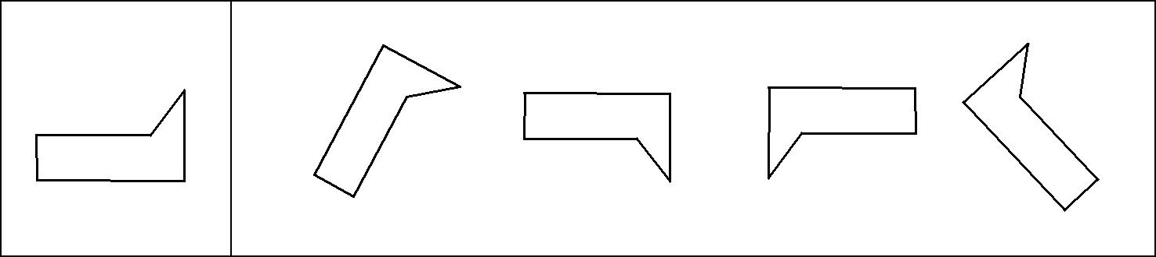

(1) (2) (3) (4)

1
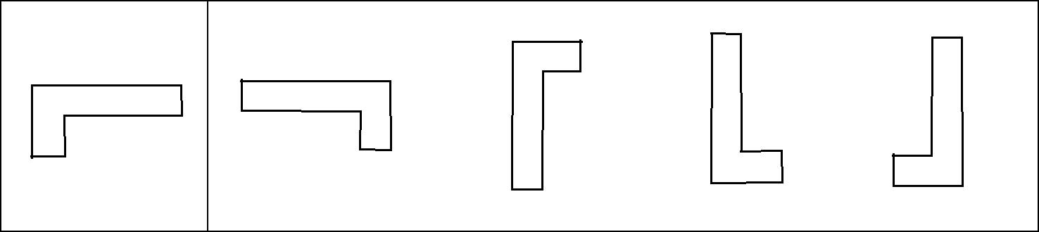

(1) (2) (3) (4)

2
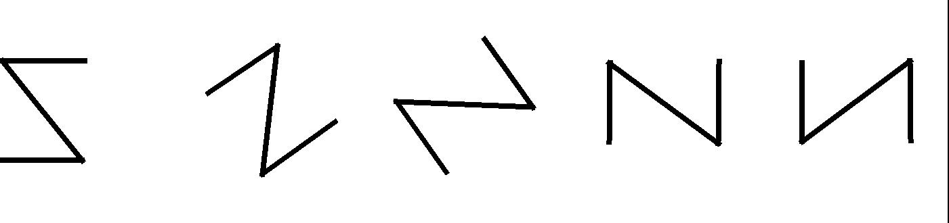

(1) (2) (3) (4)

3


(1) (2) (3) (4)

4
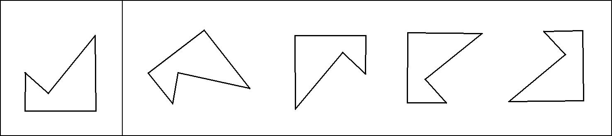

(1) (2) (3) (4)

5
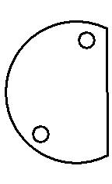
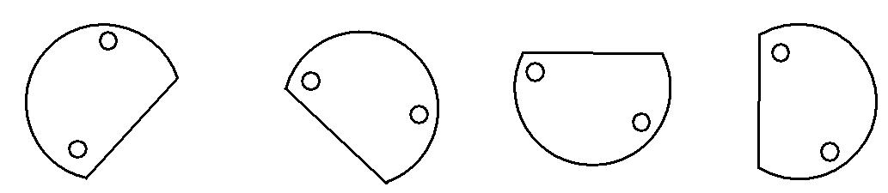

(1) (2) (3) (4)

6
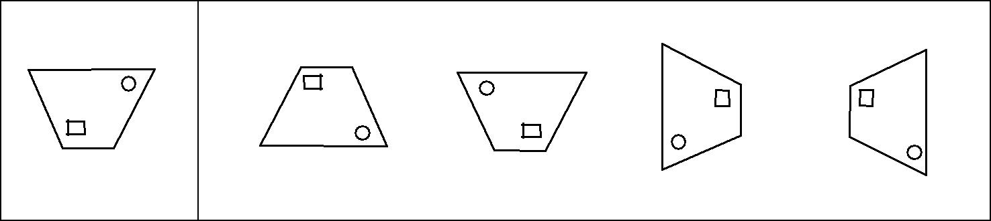

(1) (2) (3) (4)

7
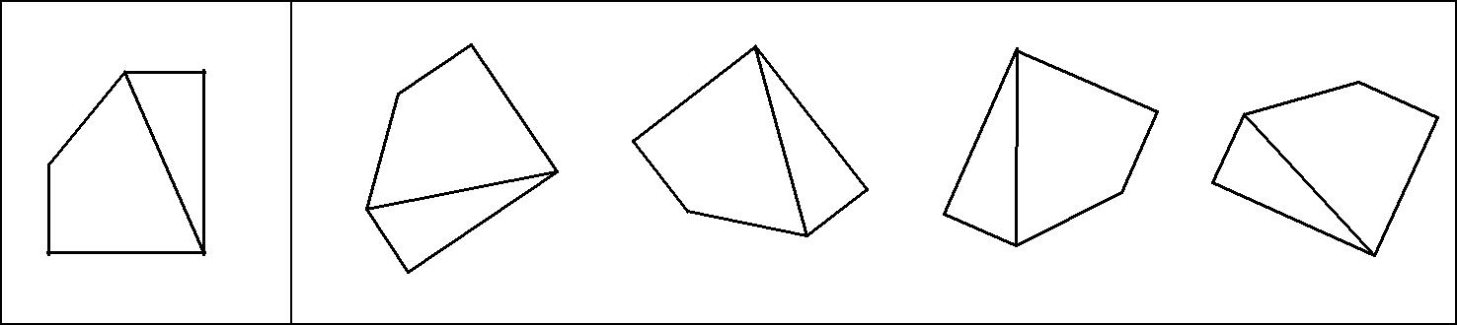

(1) (2) (3) (4)

8

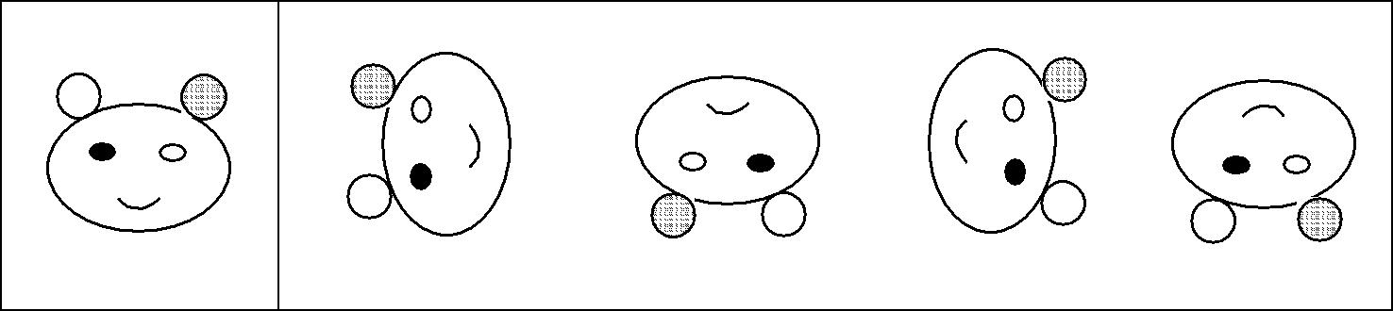

(1) (2) (3) (4)

9
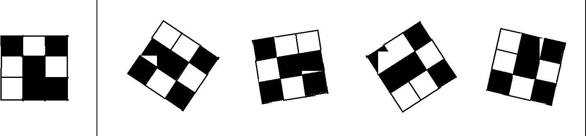

(1) (2) (3) (4)

10
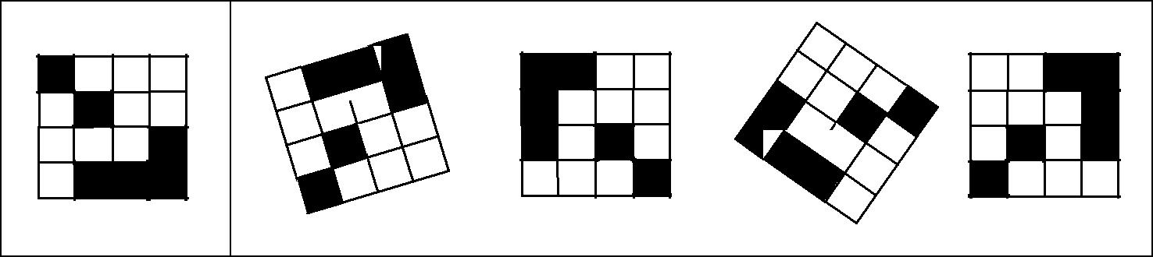

(1) (2) (3) (4)

11
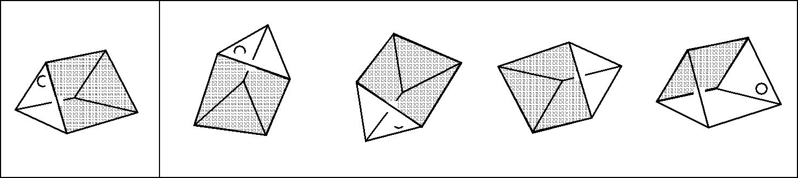

(1) (2) (3) (4)

12
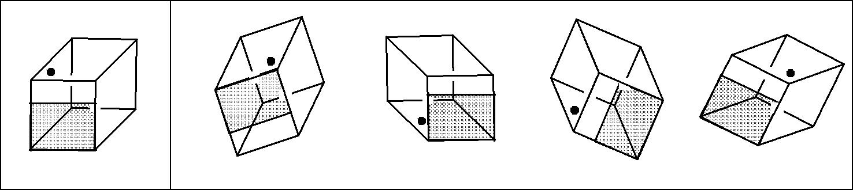

(1) (2) (3) (4)

13
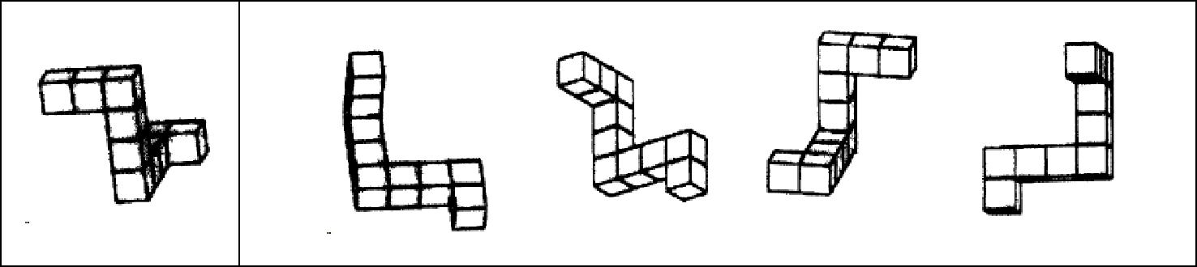

(1) (2) (3) (4)

14
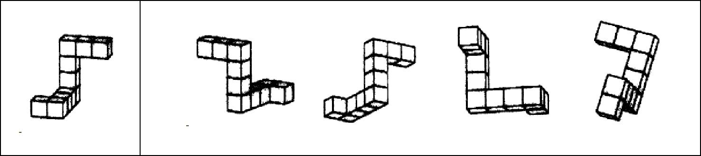

(1) (2) (3) (4)

15
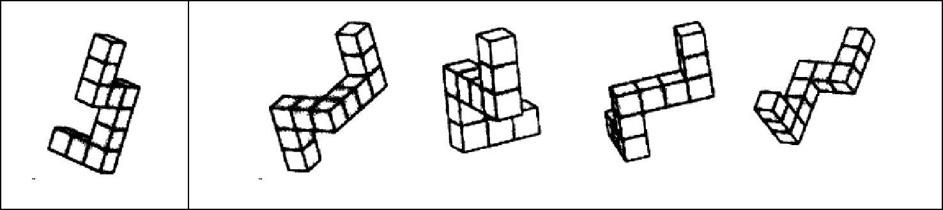

(1) (2) (3) (4)

16
